What is block?
In JavaScript, a "block" refers to a set of statements grouped together within curly braces {}. A block can contain zero or more statements, and it is commonly used to define the body of control flow structures like if statements, for loops, while loops, and functions.

What is scope?
Scope is certain region of program where a defined variable exists and can be recognized beyond that it can not be recognized Scope provides access to variable , function and objects during the run time.

Scope chain:
We can access any variable in nested scope.that is called nested scope.

What is hoisting?
Hosting is a javascript behaviour that allow us to access the variable and function before declaration.

Event loop:
The event loop is a constantly running process that monitors both callback queue and callstack.

What is closure:
It gives you access to an outer function scope from an inner function or In JavaScript, a closure is a function that has access to variables from its outer (enclosing) function, even after the outer function has finished executing. Closures are a fundamental concept in JavaScript and are often used to create private variables, maintain state, and encapsulate behavior.

What is lexical environment?
we can access the outer variable in inner scope that behavior is called lexical scope.
OR A lexical scope in javascript means that a variable defined outside a function can be accessible inside another function defined after the variable declaration. Note: According to lexical scoping, the scopes can be nested and the inner function can access the variables declared in its outer scope.
What is difference between Var, Let and Const ?
Var: We can redeclare and and we can access any where and it is function scoped
Let :We can not redeclare and and we can not access outside the scope, It is blocked scope
Const: We can not change the value of const variable and it is inaccessible outside the scope.

Callback function
The function that passed as an argument inside the another function is called as a callback function.
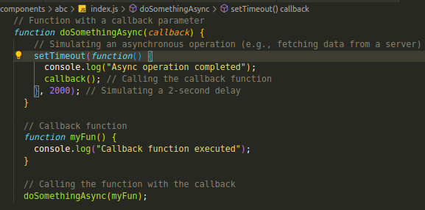

SetTimeout:
The settimeout method execute a block of code after the specified time

Memoization:
Memoization is a optimization technique that can be used to reduce time consuming calculation by saving previous input to something called cache and returning the result from it

typeof operator: typeof operator is used to determine the type of each variable.

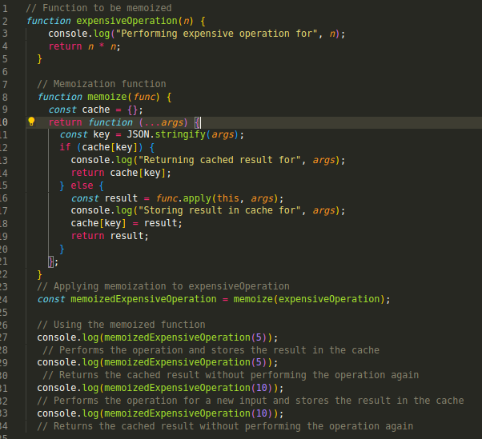
undefined:
When a variable is declared but has not been assigned a value , it is automatically initialized with undefined.
Undefined can be used when you don’t have the value right now, but you will get it after some logic or operation.

null:
Null variables are intentionally assigned the null value.
Null can be used , when you are sure you do not have any value for the particular variable.

brackets>order>division>multiplication>addition>substraction
Type coercion:
Type coercion is the automatic conversion of values from one data type to another during certain operation or comparisons. It is used during string and number concatination It is used while using comparison operator.
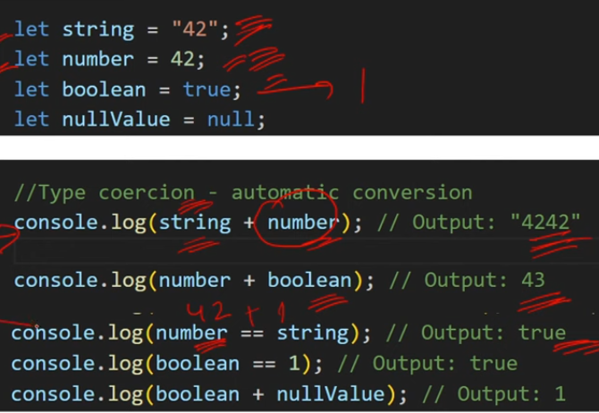

Higher order function:
A function which takes another function as an argument or return a function from it ,it is known as higher order function
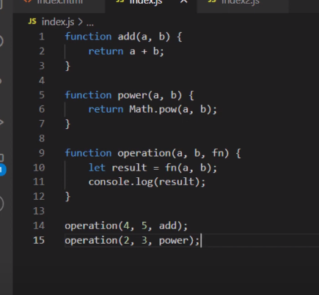
Rest operator:
The rest operator is used in function parameters to collect all remaining args into an array.
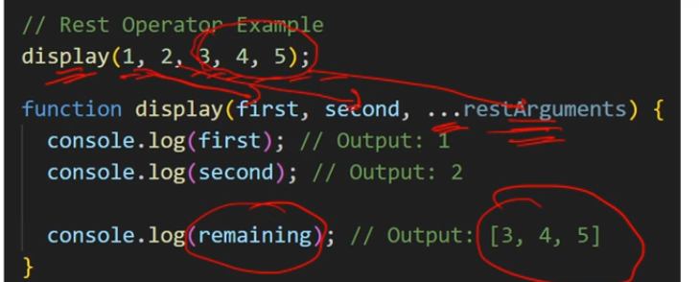

Spread operator:
It’s allows the elements of an iterable (like an array or a string) to be expanded or spread into places where multiple elements or variables are expected.
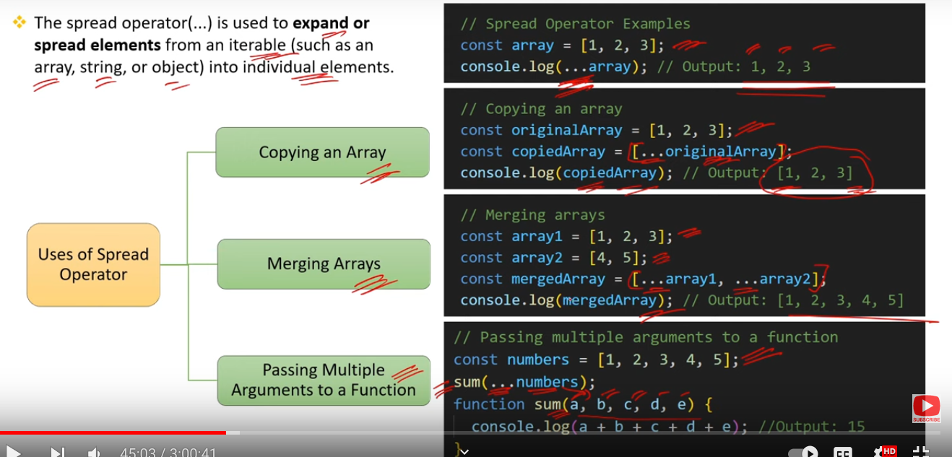

Async and await:
Async:
Async function always return a promise
The async is a keyword that is used to create async function
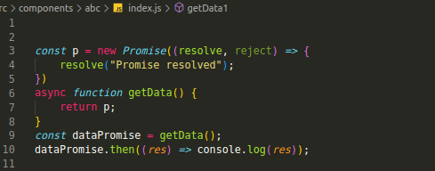
Await:
Async and await combo is used to handle promises
Await can used only inside the async function.
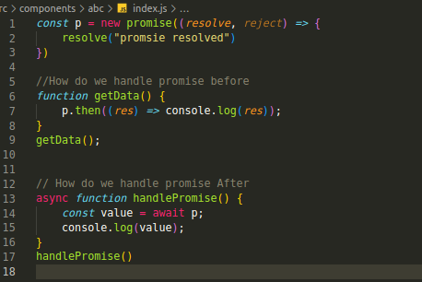

What is difference be normally handling promises and using async/await
In the case of normal promise ,the program will not wait for handle promise and code will executed b/c javascript wait for none.
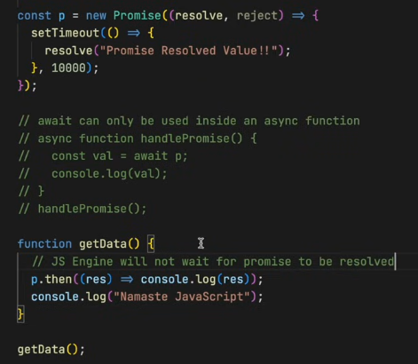
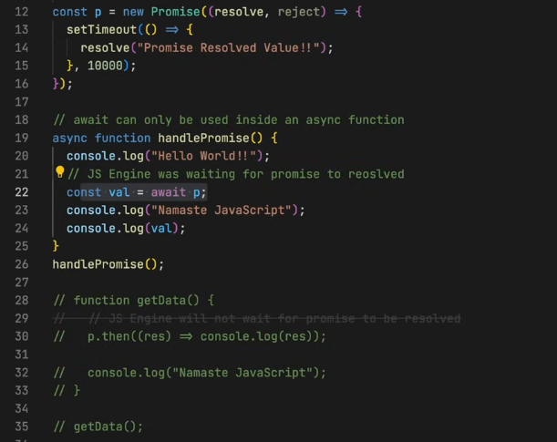

Function expression:
When you store function inside a variable it’s called a function expression

Temporal dead zone:
The Temporal Dead Zone (TDZ) is a concept in JavaScript that refers to the period between the start of a block and the declaration of a variable using let or const keywords. During this period, the variable exists in the scope but is not yet initialized and cannot be accessed. If you try to access the variable before it is declared, JavaScript will throw a ReferenceError
OR
Temporal dead zone is the time between declaration and initialization of let and const variable

Arrow fn vs Regular fn
- Syntax
- Implicit return keyword in arrow function
- We don't have args keyword inside the arrow function

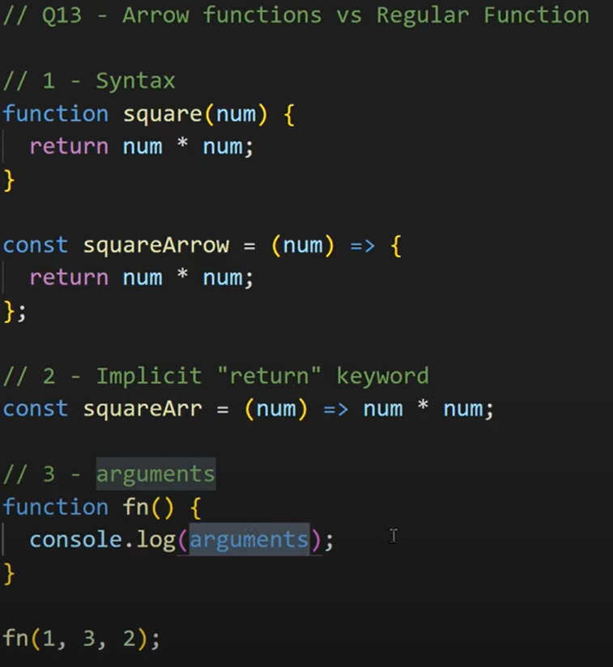
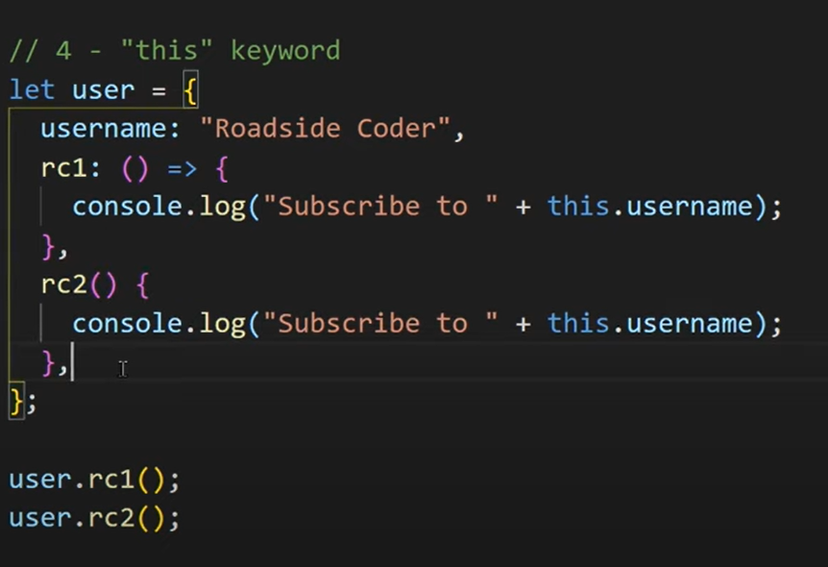

First class function
Where a function can be treated like a variable the function are called first class function
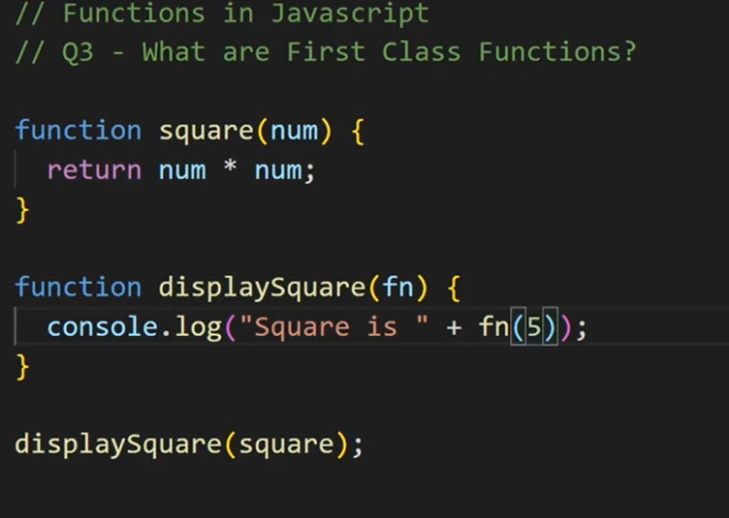

What is IIFE
where a function is defined and executed immediately after its creation. The purpose of an IIFE is to create a private scope for variables to avoid polluting the global scope and to execute code immediately.

IIFE is commonly used in scenarios where you want to create a temporary scope for variables without leaving any trace in the global scope. It's also used to create a closure, allowing the function to capture and remember the state of variables even after the IIFE has executed.

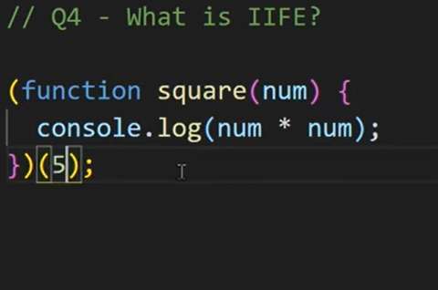

What is babel and webpack?
Babel is a transpiler which converts the code from es6 to es5.

Event propagation:
Event propagation in JavaScript refers to the process of handling events as they occur in the DOM (Document Object Model) hierarchy. There are two main phases of event propagation: capturing phase and bubbling phase.

i. Capturing Phase:
In the capturing phase, the event starts from the root of the DOM hierarchy and travels down to the target element.

Event listeners attached to ancestors of the target element are triggered during this phase.

Promise.All:
Promise.all is a method in JavaScript that allows you to execute multiple promises concurrently and wait for all of them to resolve. It takes an array of promises as an input and returns a new promise. This new promise will be fulfilled with an array of resolved values corresponding to the order of the input promises.
